NAME : DHARMIKA S COURSE : Mobile Computing
Reg No : 192421094 COURSE CODE: ITA0301

26. Design wireframes for a mobile app showcasing data replication techniques. Use Figma to demonstrate the synchronization process.

Aim:
ToDesign a mobile app showcasing data replication techniques using figma

Procedure:
- Open Figma
- Create a new file
- Select the Frames
- Design Visual Elements
- Make it Interactive
- Add icons on the Frame
- Incorporate Multimedia
- Storyboard Animation
- Review and edit the Prototype
- Save and Share

Design:
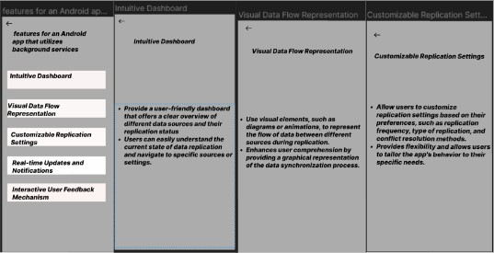

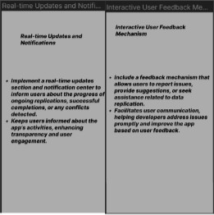

Prototype:
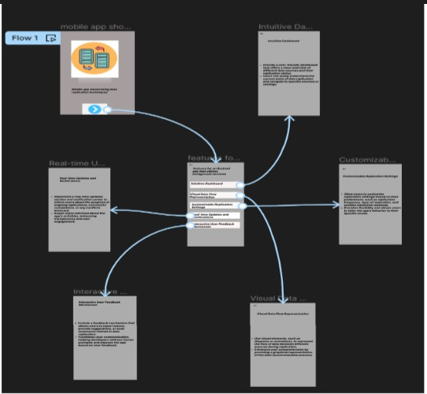

Result:
Hence a mobile app showcasing data replication techniques using figma have been created successfully

